**INVENTORY MANAGEMENT SYSTEM FOR RETAILERS**

**Domain: Cloud Application Development**

**Team ID: PNT2022TMID36552**

**Team Members:**

**Aravind – 112719104006**

**Jagadesh V - 112719104015**

**Shakthi - 112719104036**

**Saran M - 112719104033**

Deploying to Kubernetes on IBM Cloud Overview

**Overview:**

This tutorial shows how to deploy a look Back onto Kubernetes on the IBM Cloud.

**Prerequisite:**

You’ll need the following:

Node.js 10 or higher Docker 18.06 or higher

Signup for an IBM Cloud Account if you don’t have one already IBM Cloud CLI, Container registry CLI, etc

1. Kubermetes CLI ( kubecti)
2. LoopBack4CLI

Let’s install the LoopBack 4 CLI :

npm i -g @loopback/cli

# Step 1: Scaffold LoopBack 4 app

Run the lb4 app command, and specify all the values provided below.

$ lb4 app

? Project name: lb4-simple-web-app

? Project description: lb4-simple-web-app

? Project root directory: lb4-simple-web-app

? Application class name: Lb4SimpleWebAppApplication

? Select features to enable in the project (Press <space> to select, <a> to toggle all, <i> to invert selection)

* Enable eslint: add a linter with pre-configured lint rules
* Enable prettier: install prettier to format code conforming to rules
* Enable mocha: install mocha to run tests
* Enable loopbackBuild: use @loopback/build helpers (e.g. lb-eslint)
* Enable vscode: add VSCode config files
* Enable docker: include Dockerfile and .dockerignore
* Enable repositories: include repository imports and RepositoryMixin
* Enable services: include service-proxy imports and ServiceMixin (Move up and down to reveal more choices)

The lb4-simple-web-app project is created.

Navigate to the main directory of the project

cd lb4-simple-web-app

# Step 2: Run the application locally

In a command window in the main directory of your project, type:

npm start

The application will build, and then the server should start up successfully and display

Server is running at http://[::1]:3000

Try http://[::1]:3000/ping

Open your browser and attempt to access all these url

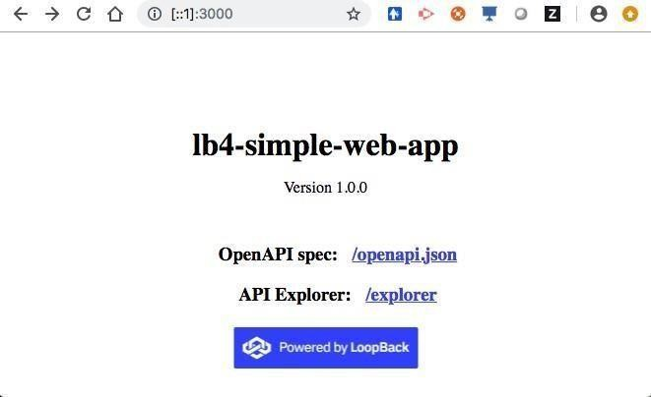http://[::1]:3000/ http://[::1]:3000/ping http://[::1]:3000/explorer http://[::1]:3000/openapi.json

Make sure that the application runs well before continuing to the next step. In the command window, stop the application with

Ctrl + C

# Step 3: Build a Docker image

Review the two Docker-related files that have been conveniently

provided, .dockerignore and Dockerfile, but leave them unchanged for this tutorial. Notice the HOST and PORT environment variable values:

ENV HOST=0.0.0.0 PORT=3000

In the package.json file, a docker:build command has been provided.

"docker:build": "docker build -t lb4-simple-web-app ."

Run the command:

npm run docker:build

When it completes, you will see :

Successfully built 7d26df6c1561

Successfully tagged lb4-simple-web-app:latest

You can find your image by typing:

docker images | grep lb4-simple-web-app

It will display something like this :

lb4-simple-web-app latest 7d26df6c1561

# Step 4: Run the application in Docker

In the package.json file, a docker:run command has been provided.

"docker:run": "docker run -p 3000:3000 -d lb4-simple-web-app"

Run the command:

npm run docker:run

Afterwards, type:

docker ps

You should see something like this:

CONTAINER ID

PORTS

IMAGE

COMMAND

CREATED

STATUS

a9962339e863 lb4-simple-web-app "node ."

8 seconds ago

Up 7 seco

nds 0.0.0.0:3000->3000/tcp

To see the log output of your container, you can type:

docker logs <container id> For example : a9962339e863

You should see something like:

Server is running at http://127.0.0.1:3000

Try http://127.0.0.1:3000/ping

Open your browser and attempt to access all these urls

http://127.0.0.1:3000/ http://127.0.0.1:3000/ping http://127.0.0.1:3000/explorer http://127.0.0.1:3000/openapi.json

# Step 5: Stop the application running in Docker

Find the container id

docker ps | grep lb4

You should see something like this:

a9962339e863 lb4-simple-web-app "node ."

The leftmost value is the container id. Type:

docker stop <container id> For example : a9962339e863

# Step 6: Log into IBM Cloud using ibmcloud login command

Use ibmcloud login command to login.

After you’ve been successfully logged in, you’ll see something like:

API endpoint:

https://api.ng.bluemix.net

Region:

us-south

User:

[dremond@ca.ibm.com](mailto:dremond@ca.ibm.com)

Account:

Dominique Emond's Account

Resource group:

default

CF API endpoint:

Org:

Space:

# Step 7: Log into IBM Cloud Container Registry

ibmcloud cr login

You should see:

Logging in to 'registry.ng.bluemix.net'... Logged in to 'registry.ng.bluemix.net'.

OK

# Step 8: Upload a docker image to the Container Registry

This requires several steps, let’s quickly go through them.

## Create a namespace

List your current namespace by typing:

ibmcloud cr namespace-list

If you want to create a new namespace for yourself, you can do so with this command:

ibmcloud cr namespace-add <my_namespace>

## Tag your local docker image with the IBM Cloud container registry

Here is the command:

docker tag <source_image>:<tag> registry.<region>.bluemix.net/<my_namespace>/<new_ image_repo>:<new_tag>

<source_image>:<tag> is what you have on your machine that you created earlier.

For example : lb4-simple-web-app:latest

registry.<region>.bluemix.net is the container registry region you logged into before.

For example : registry.ng.bluemix.net

<my_namespace> is the namespace you created for yourself For example : dremond

<new_image_repo>:<new_tag> can be whatever you want it to be; they don’t have to exist yet

For example : loopback4_webapp_repo:1

So, putting these values together, my command will look like this:

docker tag lb4-simple-web-app:latest registry.ng.bluemix.net/dremond/loopback4_web app_repo:1

## Push the local image to the container registry

docker push registry.ng.bluemix.net/dremond/loopback4_webapp_repo:1

You will see a progress bar like this:

The push refers to repository [registry.ng.bluemix.net/dremond/loopback4_webapp_re po]

478b1e842aa3: Pushed 6fd2223ea65e: Pushed

a90c4aba186a: Pushing [============>

MB/207.9MB

] 51.4

bb288a38c607: Pushed

53981d6ec3d2: Mounted from dremond/loopback4_repo

b727cac390f6: Mounted fro

Wait until it is completed.

The push refers to repository [registry.ng.bluemix.net/dremond/loopback4_webapp_re po]

478b1e842aa3: Pushed 6fd2223ea65e: Pushed a90c4aba186a: Pushed bb288a38c607: Pushed

53981d6ec3d2: Mounted from dremond/loopback4_repo b727cac390f6: Mounted from dremond/loopback4_repo df64d3292fd6: Mounted from dremond/loopback4_repo

1: digest: sha256:939ada9d1b7f6a7483aed69dff5ccc28d1931ed249b38d51d34b854b32139177

size: 1787

## Verify the image is in the container registry

Type the command :

ibmcloud cr image-list

You should see your image listed.

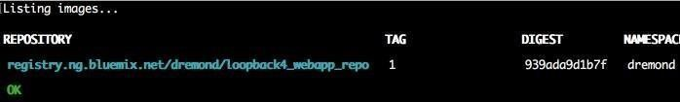

## Perform a build for the container registry

Perform a build for the container registry.

ibmcloud cr build -t registry.ng.bluemix.net/dremond/loopback4_webapp_repo:1 .

This step may fail if you have exceeded the QUOTA for images in your account. In that case clear up some room and try again.

Wait until it completes.

In your IBM Cloud account, you can view your images here Step 9: Point to your Kubernetes Cluster

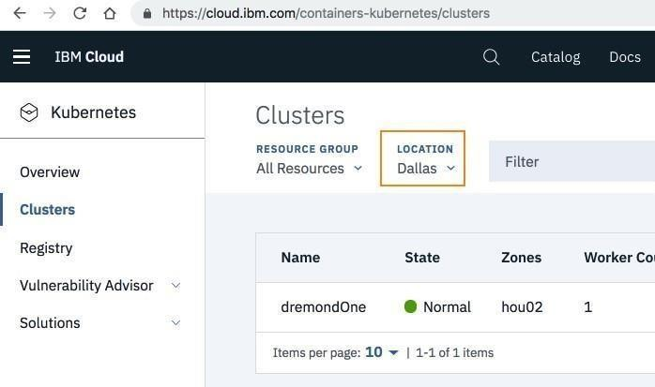In a browser, log into your IBM Cloud account, and navigate to **Kubernetes > Clusters**.

I am choosing my cluster dremondOne in Dallas .

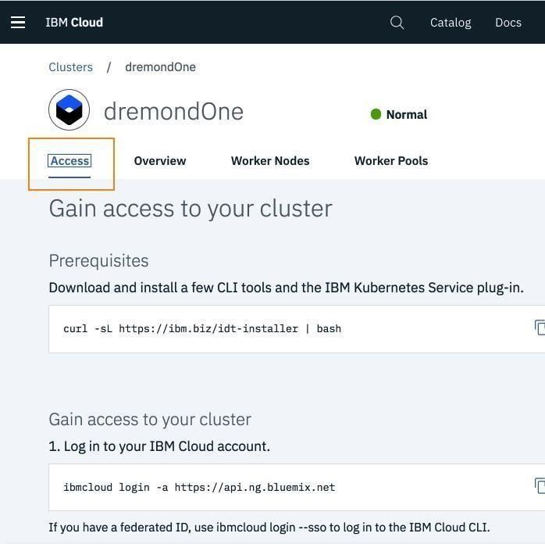We already logged into the IBM Cloud in an earlier step, so we only need to point to the cluster.

ibmcloud cs region-set us-south

ibmcloud cs cluster-config <Cluster Name>

My cluster name is **‘dremondOne’** so I see this output:

OK

The configuration for dremondOne was downloaded successfully. Export environment v ariables to start using Kubernetes.

export KUBECONFIG=/Users/dremond/.bluemix/plugins/container-service/clusters/dremo ndOne/kube-config-hou02-dremondOne.yml

Take the entire **‘export’** line above, and paste it into your command window. Now you should be able to perform Kubernetes commands like:

kubectl get nodes

You will see output like this:

|  |  |  |  |  |
| --- | --- | --- | --- | --- |
| NAME | STATUS | ROLES | AGE | VERSION |
| 10.76.193.58 | Ready | <none> | 13d | v1.10.8+IKS |

Ok, so now we are ready to deploy our Loopback4 application to Kubernetes!

# Step 10: Deploy your Loopback4 application to Kubernetes

## Create a deployment

Create a deployment named : lb4-simple-web-app-deployment ; using the image we placed in the container registry.

kubectl run lb4-simple-web-app-deployment --image=registry.ng.bluemix.net/dremond/ loopback4_webapp_repo:1

|  |  |  |  |
| --- | --- | --- | --- |
| **Verify that the pods are running** |  |  |  |
| kubectl get pods |  |  |  |
| You should see |  |  |  |
| NAME  ARTS AGE | READY | STATUS | REST |
| lb4-simple-web-app-deployment-5bfcb546d8-r7cs4 7m | 1/1 | Running | 0 |

A status of **‘Running’** is a good sign. If you have anything other than this, then there may be something wrong with your docker image , or it may have vulnerability issues you need to address.

To see the logs of your pod, type:

kubectl logs lb4-simple-web-app-deployment-5bfcb546d8-r7cs4

and you will see something like this:

Server is running at http://127.0.0.1:3000

Try http://127.0.0.1:3000/ping

## Create a service

Expose your deployment with a service named : lb4-simple-web-app-service

kubectl expose deployment/lb4-simple-web-app-deployment --type=NodePort --port=300

0 --name=lb4-simple-web-app-service --target-port=3000

## Obtain the NodePort of your service

Let’s determine the NodePort of your service.

kubectl describe service lb4-simple-web-app-service

You will see output like this:

Name:

lb4-simple-web-app-service

Namespace:

default

Labels:

run=lb4-simple-web-app-deployment

Annotations:

<none>

Selector:

run=lb4-simple-web-app-deployment

Type:

NodePort

IP:

172.21.103.26

Port:

<unset> 3000/TCP

TargetPort:

3000/TCP

NodePort:

<unset> 31701/TCP

Endpoints:

172.30.78.136:3000

Session Affinity:

None

External Traffic Policy: Cluster

Events:

<none>

In this case, the NodePort is 31701 .

## Obtain the public IP address of the cluster

Let’s determine the public IP address of the cluster

ibmcloud ks workers dremondOne

You should see something like this

|  |  |  |  |  |  |  |
| --- | --- | --- | --- | --- | --- | --- |
| OK |  |  |  |  |  |  |
| ID  tatus | Public IP | Private IP | Machine | Type | State | S |
| kube-hou02-pa45e...6-w1 eady | 184.173.5.187 | 10.76.193.58 | free |  | normal | R |

In my case, the public IP is: 184.173.5.187

So now we can formulate the url of our loopback4 application using those two pieces

:

http://184.173.5.187:31701

Open your browser and attempt to access all these urls

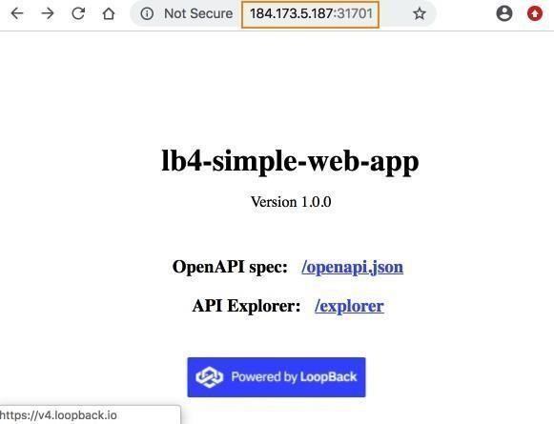

http://184.173.5.187:31701/

http://184.173.5.187:31701/ping

http://184.173.5.187:31701/explorer

http://184.173.5.187:31701/openapi.json

# Step 11: View your app in the Kubernetes Dashboard

Let’s go take a look at your application in the Kubernetes dashboard. Click the **‘Kubernetes Dashboard’** button next to your cluster’s name.

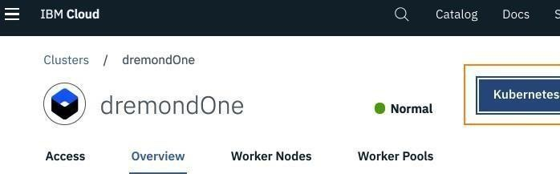Under **‘Workloads’**, select **‘Pods’**

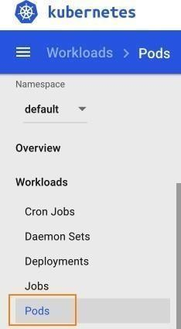

Locate your application, and click on its name

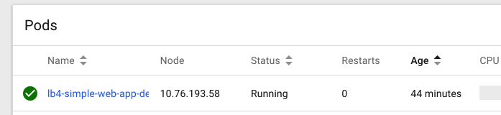If you want to open a shell into the container in the pod, click on the EXEC button.

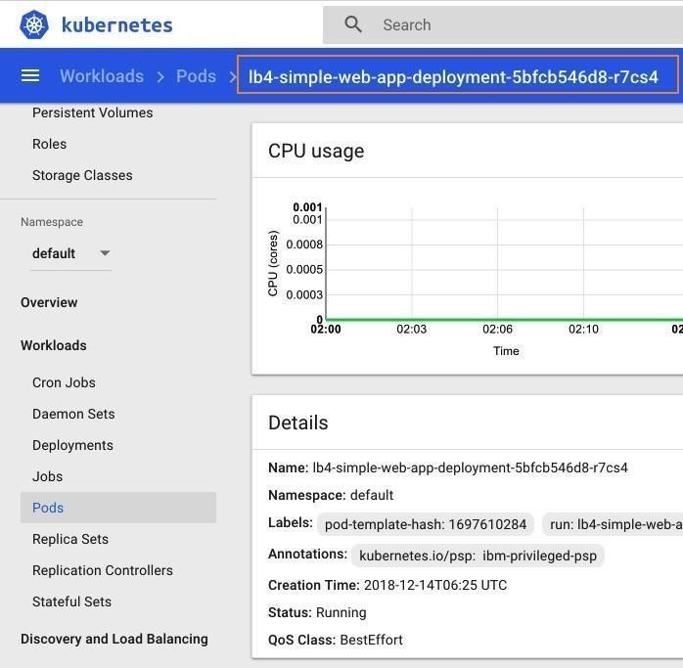If you want to view the logs of the container in the pod, click on the LOGS button.

So there you have it! You have successfully deployed a Loopback4 application to Kubernetes on the IBM Cloud.